**F-STWR2.1.5（Windows） Operation Manual**

**Remember to set the installation path to the environment variable PATH**

**Operation steps：**

1. **Input Data file：*.csv (format) (TestData is in the floder : ./test_data/exe_test/ )**

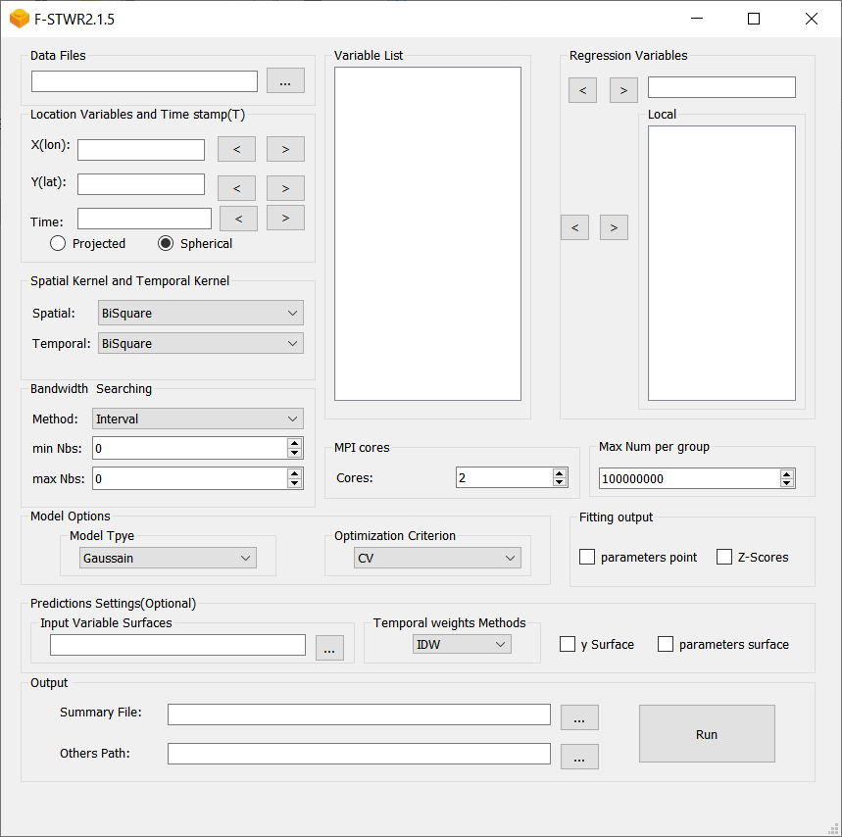

1. **Set the coordinates, dependent, independent and time variables**

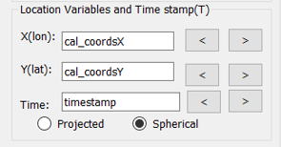 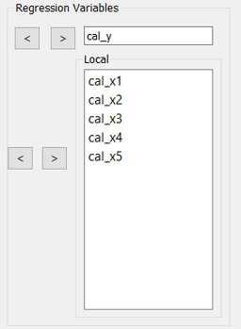

1. **Set the spatial kernel and temporal kernel, now you can only the same kernel (We recommend that you temporarily use the default).**

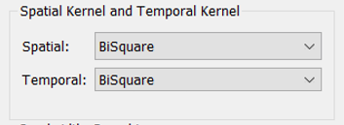

1. **Set the Bandwidth Searching method (We recommend that you temporarily use the default).**

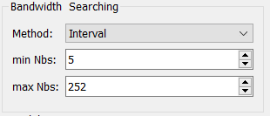

1. **Set whether to output the fitting parameters points and its z-scores values. The default output path is the same as the “summary file directory”.**

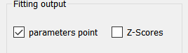

1. **Set whether do prediction or model fitting. If you need prediction, the “Input Variable Surfaces” field should be specified to a folder path, in which the file names of the arguments in all Variable Lists. Take an example, you can set a folder path as below:**

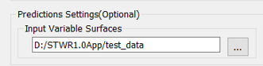

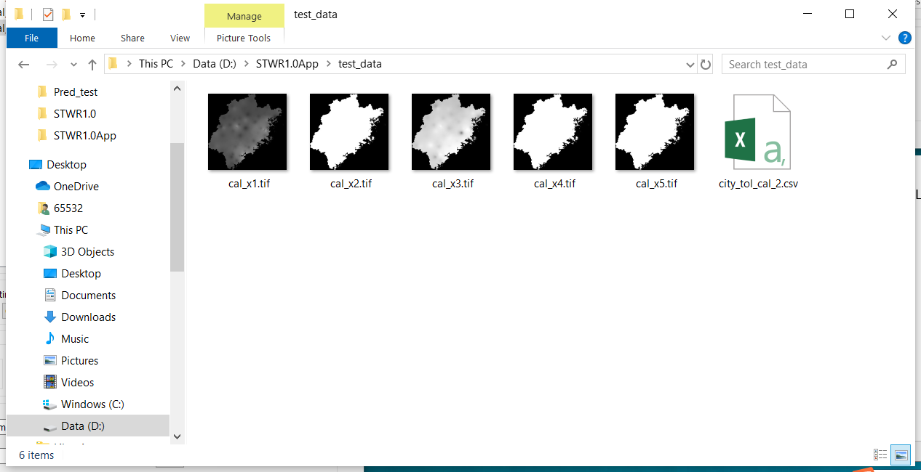

1. **Set the parameter number of “MPI cores” according to your computer core number.**

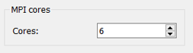

1. **If your computer memory is not enough, set the field “MaxNum per group” with a smaller number like 2000000.**

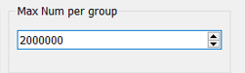

1. **Check whether to predict the coefficient surfaces of independent variables to the dependent variable.**

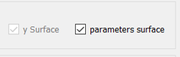

1. **Set the output path.**

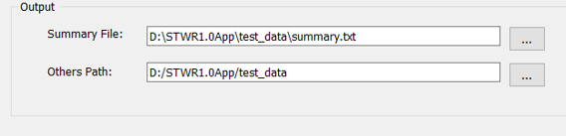

1. **Check all the settings and make sure Make sure these settings are what you want.**

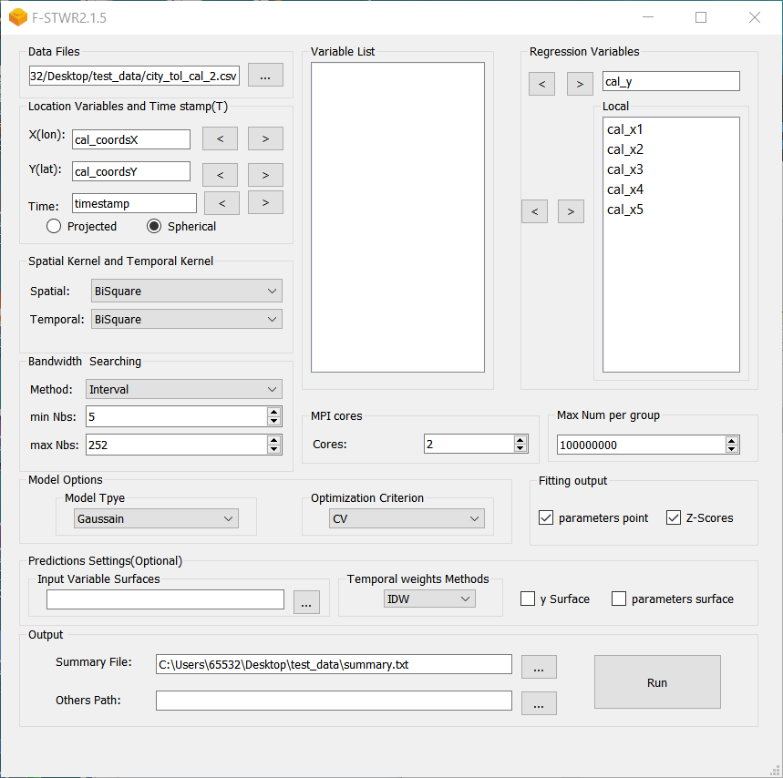

1. **Push the Run button and wait for the result. See the output files in the output path your previous set.**

